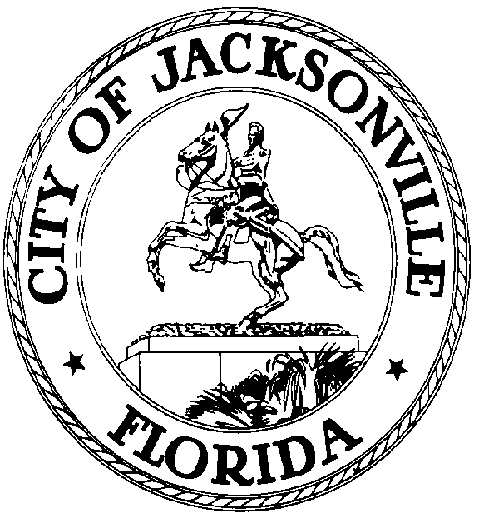

GARRETT L. DENNIS
Council Member District 9
E-Mail: GarrettD@coj.net

OFFICE OF THE CITY COUNCIL
117 West Duval Street City Hall, Suite 425
Jacksonville, Florida 32202
Office (904) 255-5209
Fax (904) 255-5230

MEDIA RELEASE

FOR IMMEDIATE RELEASE – March 10, 2020
Contact: Taryn Roberts (904) 255 -5161, TGRoberts@coj.net

COUNCIL MEMBER GARRETT DENNIS HOMESTEAD EXEMPTION BILL PASSES UNANIMOUSLY

JACKSONVILLE, Fla. – Following a discussion at the City Council meeting, Bill 2020-0117 passed unanimously.

This bill increases the amount of homestead exemption for low income persons 65 and over from $25,000 to $50,000. The Property Appraiser’s Office estimates that the additional $25,000 exemption would apply to 2,476 senior-owned properties.

“Passing this bill gives the City the ability to assist citizens with the greatest of need. The additional $25,000 exemption will go a long way and we need to do everything as an elected body to help,” said Council Member Garrett Dennis.

